**ABSTRACT**

This paper is scrutinizes the use of different concepts of packages and interfaces in Advance Java Programming, enabling viewer to get the complete concept of different aspects of Advance Java Programming To satisfy this we have created a Text Editor program using Java. It is done by importing packages and interfaces of various classes available in advance java its is also GUI based which is also used as a reference to the output, satisfying every need of a perfect microproject..

**INDEX**

|  |  |  |
| --- | --- | --- |
| **Sr. No.** | **Contents** | **Page No.** |
| 1. | Introduction | 3 |
| 2. | Code | 6 |
| 3. | Result | 10 |
| 4. | Conclusion | 14 |
| 5. | Reference | 15 |

**Chapter-1**

**INTRODUCTION**

1. **Java:**

Java is a high-level, class-based, object-oriented programming language that is designed to have as few implementation dependencies as possible. It is a general-purpose programming language intended to let programmers write once, run anywhere (WORA), meaning that compiled Java code can run on all platforms that support Java without the need for recompilation. Java applications are typically compiled to bytecode that can run on any Java virtual machine (JVM) regardless of the underlying computer architecture. The syntax of Java is similar to C and C++, but has fewer low-level facilities than either of them. The Java runtime provides dynamic capabilities (such as reflection and runtime code modification) that are typically not available in traditional compiled languages. As of 2019, Java was one of the most popular programming languages in use according to GitHub, particularly for client–server web applications, with a reported 9 million developers.

Java was originally developed by James Gosling at Sun Microsystems (which has since been acquired by Oracle) and released in 1995 as a core component of Sun Microsystems' Java platform. The original and reference implementation Java compilers, virtual machines, and class libraries were originally released by Sun under proprietary licenses. As of May 2007, in compliance with the specifications of the Java Community Process, Sun had relicensed most of its Java technologies under the GPL-2.0-only license. Oracle offers its own HotSpot Java Virtual Machine, however the official reference implementation is the OpenJDK JVM which is free open-source software and used by most developers and is the default JVM for almost all Linux distributions.

**Fig.1. Java**

1. **Text Editor:**

A text editor is a type of computer program that edits plain text. Such programs are sometimes known as "notepad" software, following the naming of Microsoft Notepad. Text editors are provided with operating systems and software development packages, and can be used to change files such as configuration files, documentation files and programming language source code. There are important differences between plain text (

and rich text.

Plain text exclusively consists of character representation. Each character is represented by a fixed-length sequence of one, two, or four bytes, or as a variable-length sequence of one to four bytes, in accordance to specific character encoding conventions, such as ASCII, ISO/IEC 2022, UTF-8, or Unicode. These conventions define many printable characters, but also non-printing characters that control the flow of the text, such as space, line break, and page break. For compatibility reasons, this tradition has not changed.

Rich text, on the other hand, may contain metadata, character formatting data (e.g. typeface, size, weight and style), paragraph formatting data (e.g. indentation, alignment, letter and word distribution, and space between lines or other paragraphs), and page specification data (e.g. size, margin and reading direction). Rich text can be saved in binary format.

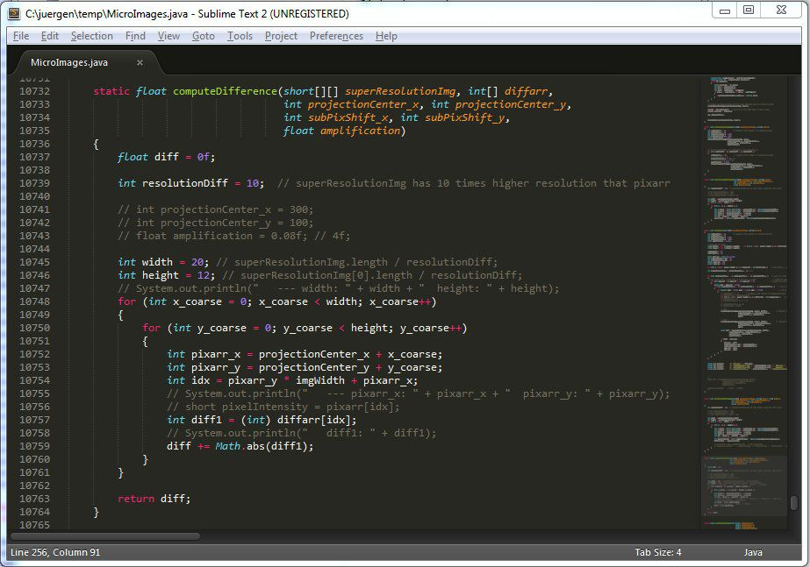

**Fig.2. Text Editor**

**Chapter-2**

**CODE**

**Editor.java**

**import java.awt.*;**

**import javax.swing.*;**

**import java.io.*;**

**import java.awt.event.*;**

**import javax.swing.plaf.metal.*;**

**import javax.swing.text.*;**

**class editor extends JFrame implements ActionListener {**

**JTextArea t;**

**JFrame f;**

**editor()**

**{**

**f = new JFrame("editor");**

**try {**

**UIManager.setLookAndFeel("javax.swing.plaf.metal.MetalLookAndFeel");**

**MetalLookAndFeel.setCurrentTheme(new OceanTheme());**

**}**

**catch (Exception e) {**

**}**

**t = new JTextArea();**

**JMenuBar mb = new JMenuBar();**

**JMenu m1 = new JMenu("File");**

**JMenuItem mi1 = new JMenuItem("New");**

**JMenuItem mi2 = new JMenuItem("Open");**

**JMenuItem mi3 = new JMenuItem("Save");**

**JMenuItem mi9 = new JMenuItem("Print");**

**mi1.addActionListener(this);**

**mi2.addActionListener(this);**

**mi3.addActionListener(this);**

**mi9.addActionListener(this);**

**m1.add(mi1);**

**m1.add(mi2);**

**m1.add(mi3);**

**m1.add(mi9);**

**JMenu m2 = new JMenu("Edit");**

**JMenuItem mi4 = new JMenuItem("cut");**

**JMenuItem mi5 = new JMenuItem("copy");**

**JMenuItem mi6 = new JMenuItem("paste");**

**mi4.addActionListener(this);**

**mi5.addActionListener(this);**

**mi6.addActionListener(this);**

**m2.add(mi4);**

**m2.add(mi5);**

**m2.add(mi6);**

**JMenuItem mc = new JMenuItem("close");**

**mc.addActionListener(this);**

**mb.add(m1);**

**mb.add(m2);**

**mb.add(mc);**

**f.setJMenuBar(mb);**

**f.add(t);**

**f.setSize(500, 500);**

**f.show();**

**}**

**public void actionPerformed(ActionEvent e)**

**{**

**String s = e.getActionCommand();**

**if (s.equals("cut")) {**

**t.cut();**

**}**

**else if (s.equals("copy")) {**

**t.copy();**

**}**

**else if (s.equals("paste")) {**

**t.paste();**

**}**

**else if (s.equals("Save")) {**

**JFileChooser j = new JFileChooser("f:");**

**int r = j.showSaveDialog(null);**

**if (r == JFileChooser.APPROVE_OPTION) {**

**File fi = new File(j.getSelectedFile().getAbsolutePath());**

**try {**

**FileWriter wr = new FileWriter(fi, false);**

**BufferedWriter w = new BufferedWriter(wr);**

**w.write(t.getText());**

**w.flush();**

**w.close();**

**}**

**catch (Exception evt) {**

**JOptionPane.showMessageDialog(f, evt.getMessage());**

**}**

**}**

**else**

**JOptionPane.showMessageDialog(f, "the user cancelled the operation");**

**}**

**else if (s.equals("Print")) {**

**try {**

**t.print();**

**}**

**catch (Exception evt) {**

**JOptionPane.showMessageDialog(f, evt.getMessage());**

**}**

**}**

**else if (s.equals("Open")) {**

**JFileChooser j = new JFileChooser("f:");**

**int r = j.showOpenDialog(null);**

**if (r == JFileChooser.APPROVE_OPTION) {**

**File fi = new File(j.getSelectedFile().getAbsolutePath());**

**try {**

**String s1 = "", sl = "";**

**FileReader fr = new FileReader(fi);**

**BufferedReader br = new BufferedReader(fr);**

**sl = br.readLine();**

**while ((s1 = br.readLine()) != null) {**

**sl = sl + "\n" + s1;**

**}**

**t.setText(sl);**

**}**

**catch (Exception evt) {**

**JOptionPane.showMessageDialog(f, evt.getMessage());**

**}**

**}**

**else**

**JOptionPane.showMessageDialog(f, "the user cancelled the operation");**

**}**

**else if (s.equals("New")) {**

**t.setText("");**

**}**

**else if (s.equals("close")) {**

**f.setVisible(false);**

**}**

**}**

**public static void main(String args[])**

**{**

**editor e = new editor();**

**}**

**}**

**Chapter-3**

**RESULT**

Fig.1. Editor

Fig.2. Menu

Fig.3. Menu II

Fig.4.Open

Fig.5. Save

Fig.6.Cancel

Fig.7. Print

Fig.8. Print II

Fig.9. Print III

Fig.10. Cut, Copy,Paste

**CONCLUSION**

Java is an object-oriented programming language. It is a general-purpose programming language, mainly designed to run developed java code on all platforms that support Java without recompilation.

As we all know, Java is one of the most popular and in-demand programming languages to learn and it was one of the first languages to standardise high-level threading utilities.

Java project is a must for aspiring developers. This project helps developers develop real-world projects to hone their skills and materialise their theoretical knowledge into practical experience. Java has significant advantages both as a commercial language and also as a teaching language. Java project provides rigorous compile-time error checking typically associated with Pascal, allowing instructors to introduce students to GUI programming, networking, threads, and other important concepts used in modern-day software. Overall, the java project gives a complete design for the extended language.

**REFERENCES**

1. https://en.wikipedia.org/wiki/Text_editor
2. https://en.wikipedia.org/wiki/Java
3. https://byjus.com/questions/conclusion-for-java-project/